create table DEPT (

    DEPTNO numeric (2),

    DNAME varchar (30),

    LOC varchar (20)

);

create table EMP (

EMPNO numeric (6),

ENAME varchar (20),

    JOB varchar (10),

    DEPTNO numeric (2),

    SAL numeric (7,2),

    primary key (EMPNO),

    foreign key (DEPTNO) references DEPT(DEPTNO)

);

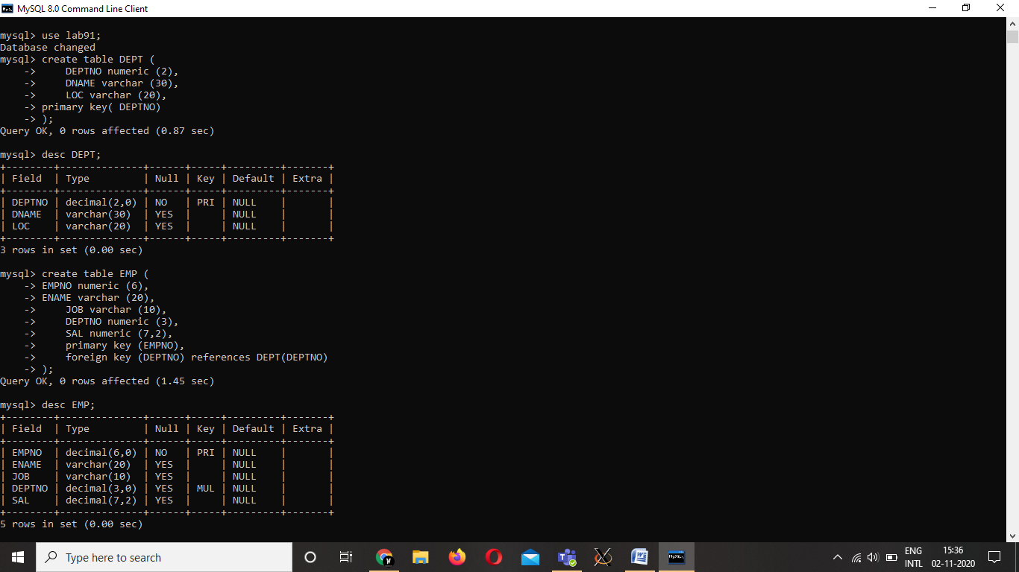

insert into EMP values

(1, 'Anand', 'AppDev', 1, 80000.00),

(2, 'Rajath', 'AppDev', 1, 60000.00),

(3, 'Joel', 'AppDev', 1, 60000.00),

(4, 'Anandhu', 'Analyst', 2, 35000.00),

(5, 'Adil', 'Analyst', 2, 35000.00),

(6, 'Thejas', 'Temp', 3, 10000.00),

(7, 'Raju', 'Temp', 4, 10000.00);

insert into DEPT values ( 1, "CSE" , "Chennai") , ( 2  , " ECE" , "Mumbai" ) , ( 3 , "EEE" , "Delhi") , ( 4 , "MECH" , "Mumbai");

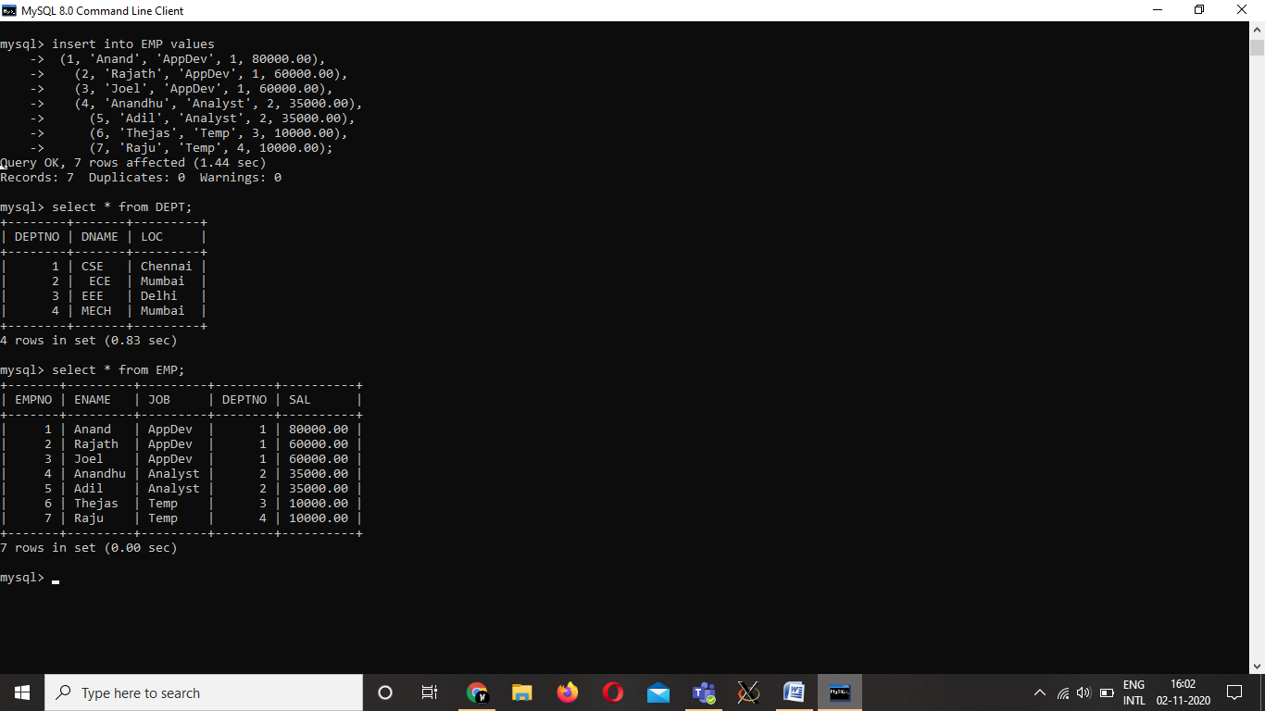

1. Create a procedure to display the details of an employee record form employee table for a

given employee number.

|  |
| --- |
|  |

create procedure DisplayEmployeeDetails(in employeeNumber numeric (6))

-> SELECT *

-> FROM EMP

-> WHERE EMP.EMPNO = employeeNumber;

2. Create a procedure to add details of a new employee into employee table

create procedure AddEmployee(

    in empNo numeric (6),

    in empName varchar (20),

    in job varchar (10),

    in deptNo numeric (2),

    in sal numeric (7,2))

insert into EMP

values (empNo, empName, job, deptNo, sal);

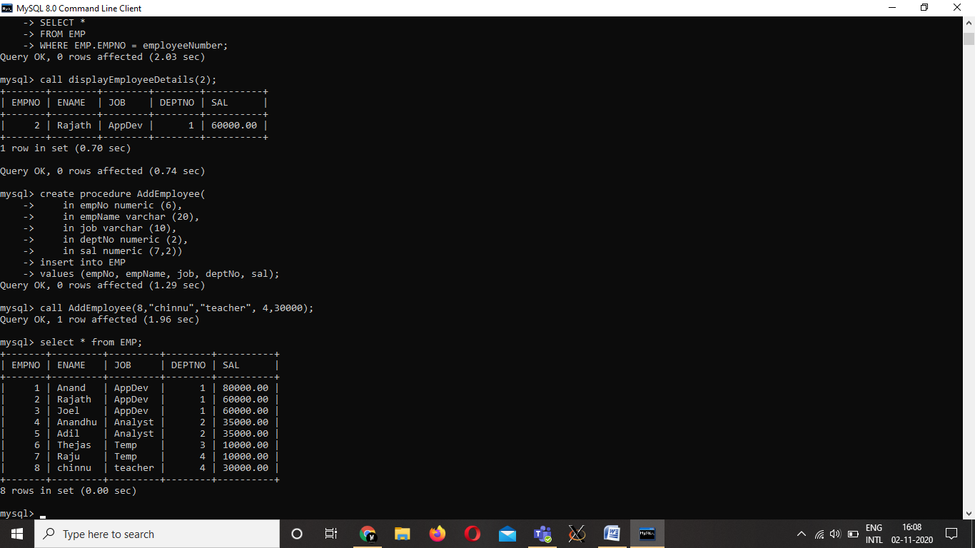

3. Write a procedure raise_sal which increases the salary of an employee. It accepts an employeecnumber and salary increase amount. It uses the employee number to find the current salary from the EMPLOYEE table and update the salary.

create procedure raise_sal ( in employeeNumber numeric(6) , in salary_raise numeric(7 ,2))

    update EMP set sal = sal + salary_raise where EMP.EMPNO = employeeNumber;

4. Create a procedure to delete a record form employee table for a given employee name.

create procedure delete_record ( in employeeNumber numeric(6) )

delete from EMP where EMP.EMPNO = employeeNumber;

call delete_record ( 8);

5. Write a function to display minimum salary of employees from the employee table.

delimiter //

create function MinSalary() returns numeric(7,2) DETERMINISTIC

begin

declare minSal numeric(7,2);

select min(SAL) into minSal from EMP;

return minSal;

end;//delimiter ;

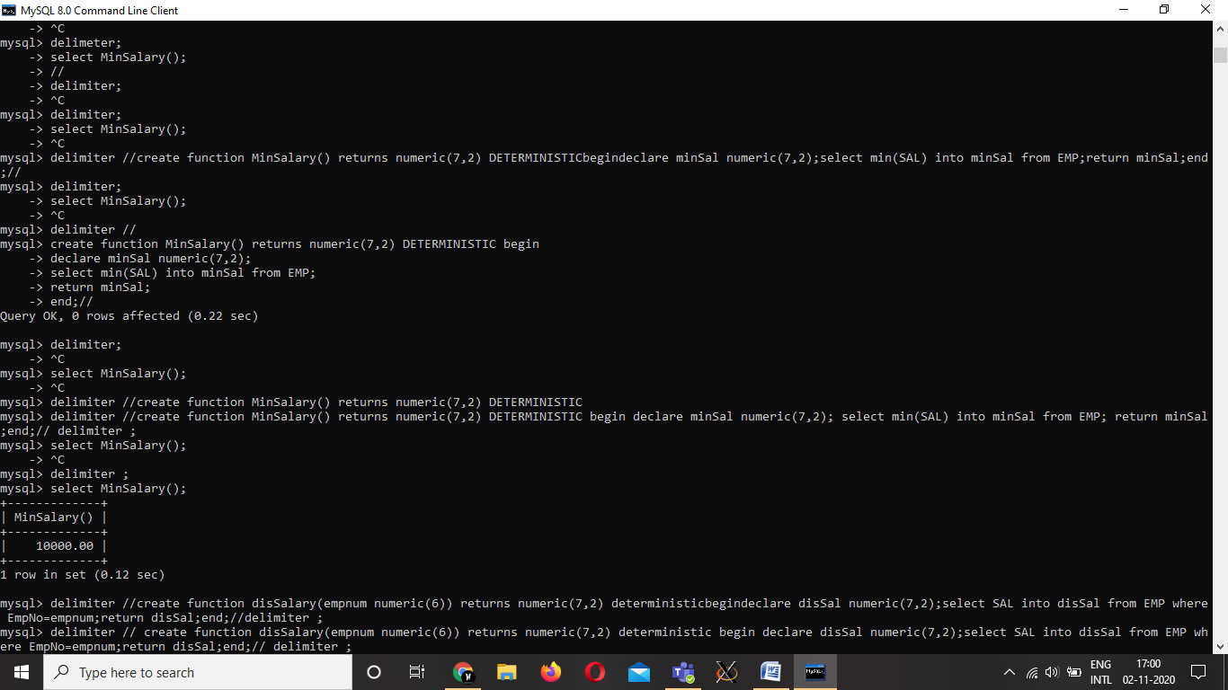

6. Write a function to display salary of an employee with the given employee number = 5.

delimiter //

create function Display_Salary( employeeNumber numeric(6)) returns numeric(7 , 2) DETERMINISTIC

begin

    declare ans numeric ( 7 ,2);

    select (SAL) into ans from EMP where EMP.EMPNO = employeeNumber;

    return ans;

end;//

delimiter ;

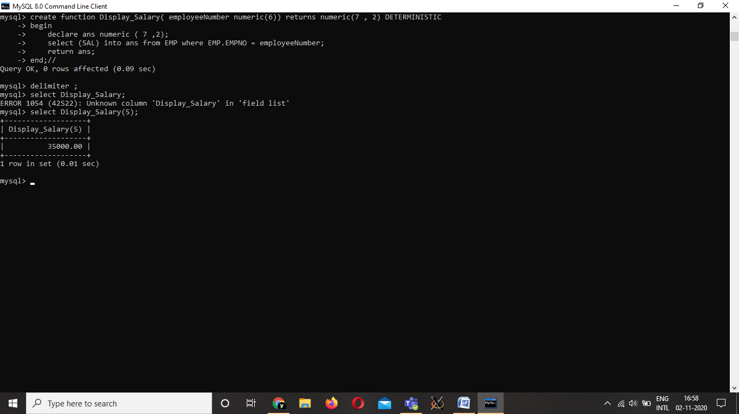

7. Write a function average which takes DeptNo as input argument and returns the average salary received by the employee in the given department.

delimiter //

create function Avgg ( departmentNumber numeric (2) ) returns numeric ( 7 , 2)

deterministic

begin

    declare ans numeric(7 ,2);

    select avg(SAL) into ans from EMP where EMP.DEPTNO = departmentNumber;

    return ans;

end; //

delimiter ;

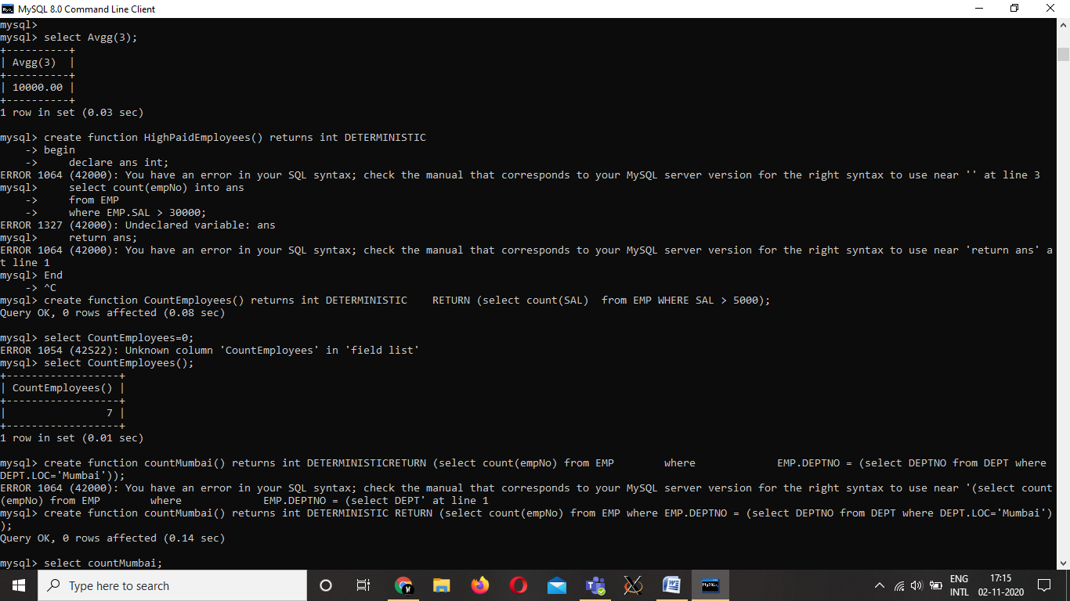

8. Write procedure that lists the highest salary drawn by an employee in each of the

departments. It should make use of a named procedure dept_highest which finds the highest

salary drawn by an employee for the given department.

delimiter //

create function HighestPaid(deptNo numeric (2)) returns numeric(7,2) DETERMINISTIC

begin

declare ans numeric(7,2);

select max(SAL) into ans

from EMP

where EMP.DEPTNO=deptNo;

return ans;

end; //

delimiter ;

create procedure ShowAllSalary()

select HighestPaid(DEPTNO) from DEPT;

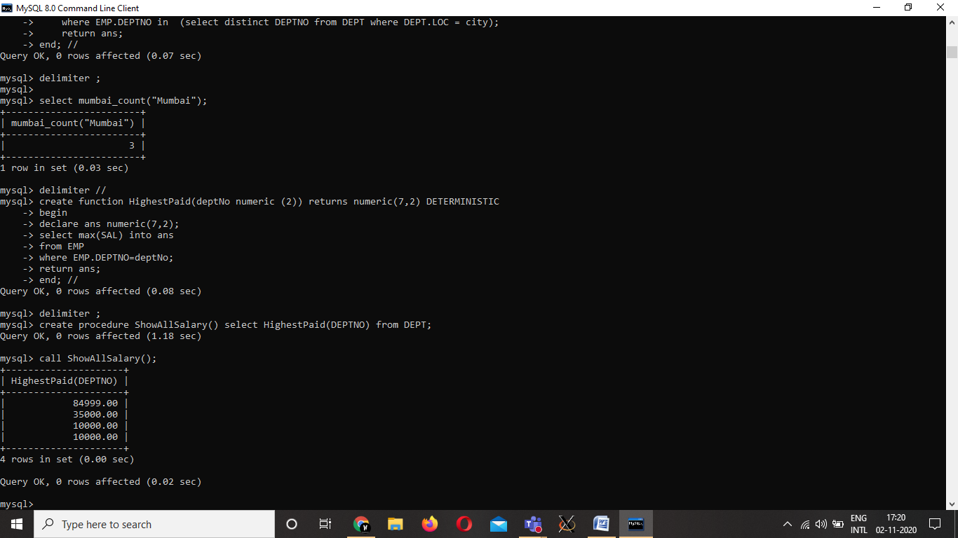

9. Write a function that will display the number of employees with salary more than 30000

delimiter //

create function HighPaidEmployees() returns int DETERMINISTIC

begin

    declare ans int;

    select count(empNo) into ans

    from EMP

    where EMP.SAL > 30000;

    return ans;

end; //

delimiter ;

.

10. Write a function that will display the count of the number of employees working in Mumbai.

delimiter //

Create function mumbai_count ( city varchar(20)) returns numeric(3) DETERMINISTIC

begin

declare ans numeric(3);

select count(empNo) into ans

    from EMP

    where EMP.DEPTNO in  (select distinct DEPTNO from DEPT where DEPT.LOC = city);

    return ans;

end; //

delimiter ;

